Syria-stocks.com's three-month global Alexa traffic rank is 93,277. This site has a bounce rate of about 16% (i.e., 16% of visits consist of only one pageview). Visitors to it spend roughly 52 minutes per visit to the site and 72 seconds per pageview. We estimate that 65% of this site's visitors are in Syria, where it has attained a traffic rank of 122. Syria-stocks.com's content places it in the “المال والاعمال” category of websites.
5 Stars  1 Review Average Review  The average review of syria-stocks.com based on user ratings. | 93,277  Alexa Traffic Rank Alexa Traffic Rank  A measure of syria-stocks.com's popularity.  The rank is calculated using a combination of average daily visitors to syria-stocks.com and pageviews on syria-stocks.com over the past 3 months. The site with the highest combination of visitors and pageviews is ranked #1.  Updated Daily | 122  Traffic Rank in SY Traffic Rank in Country  A measure of syria-stocks.com's popularity in a specific country. The complete list of syria-stocks.com's ranks by country is on the 'Traffic Stats' tab below.  The rank by country is calculated using a combination of average daily visitors to syria-stocks.com and pageviews on syria-stocks.com from users from that country over the past 3 months. The site with the highest combination of visitors and pageviews is ranked #1 in that country.  Updated Daily | 16  Sites Linking In Sites Linking In  A measure of syria-stocks.com's reputation.  The number of links to syria-stocks.com from sites visited by users in the Alexa traffic panel. Links that were not seen by users in the Alexa traffic panel are not counted. Multiple links from the same site are only counted once.  Updated Quarterly
- Traffic Stats
- Search Analytics
- Audience
- Contact Info
- Reviews
- Related Links
- Clickstream

- Traffic Rank
- Reach
- Pageviews
- Pageviews/User
- Bounce %
- Time on Site
- Search %
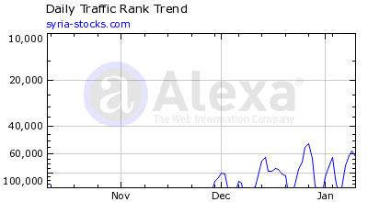
Alexa traffic rank for syria-stocks.com:
 | Traffic Rank | Change
7 day | 70,673 | +1,772
1 month | 68,651 | -42,626
3 month | 93,277 | -31,671
Percent of global pageviews on syria-stocks.com:
 | Pageviews | Change
7 day | 0.00040 | -4%
1 month | 0.00049 | +78%
3 month | 0.00033 | +130%
Percent of global Internet users who visit syria-stocks.com:
 | Reach | Change
7 day | 0.00160 | +2%
1 month | 0.00151 | +60%
3 month | 0.00112 | +26%
The percentage of visits to syria-stocks.com that consist of a single pageview:
 | Bounce % | Change
7 day | 11.90000 | +7%
1 month | 13.30000 | -30%
3 month | 16.30000 | -23%
Daily pageviews per user for syria-stocks.com:
 | Pageviews/User | Change
7 day | 27.00000 | -6%
1 month | 33.00000 | +11%
3 month | 30.00000 | +82%
Daily time on site for syria-stocks.com:
 | Time on Site | Change
7 day | 45.75667 | +8%
1 month | 56.39833 | +6%
3 month | 52.37000 | +43%
The percentage of visits to syria-stocks.com that came from a search engine:
 | Search % | Change
7 day | 1.50000 | -12%
1 month | 1.70000 | -39%
3 month | 2.60000 | -53%
Compare syria-stocks.com to:

Share this:
Learn more about Alexa Traffic Stats.

Average Load Time for Syria-stocks.com
Very Slow (7.691 Seconds), 99% of sites are faster.
Note: Slow sites may be penalized by search engines.

Syria-stocks.com’s Worldwide Traffic Rank
Country
Rank
Syrian Arab Republic
122
United Arab Emirates
4,758
Germany
14,433
Egypt
31,006

Where Visitors Go on Syria-stocks.com
No data available for syria-stocks.com

Audience Snapshot

Top Search Queries for Syria-stocks.com

Based on internet averages, syria-stocks.com is visited more frequently by males who are in the age range 25-34, have children, are college educated and browse this site from work.
View the full Audience Profile
View the complete Search Analytics

Is this your website?
- Update your listing data using our Self-service tools
- Improve your SEO with an Alexa Site Audit for syria-stocks.com.

Search Traffic
The percentage of site visits from search engines.
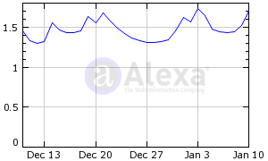
Period | Percent of Site Traffic

Last 30 days | 1.7%
Last 7 days | 1.5%
Yesterday | 5.6%

